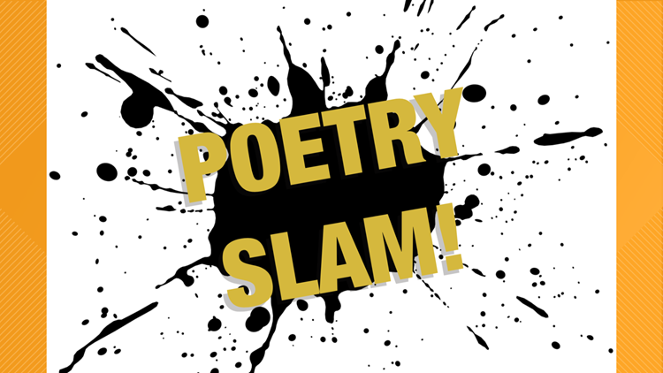

The Ferguson Library Youth Services Department Presents
A Teen Poetry Slam
Friday, May 3, 2024 * 2:00 pm until 3:30 pm
3rd Floor Dudley N. Williams, Jr. Auditorium
Sign up in advance at mlee@fergusonlibrary.org or the youth services desk on the lower level
by Friday April 26, 2024.

